Assignment 6: Medians and Order Statistics & Elementary Data Structures

Geetha Lahari Barlapudi
University of the Cumberlands
Algorithms and Data Structures
Michael Solomon
22-10-2026

Introduction
This report compares two different methods of selecting the k-th smallest element as well as giving an overview of implementations of some basic data structures in the Python programming language. This work builds on the brief for assignment of deterministic and random selection, performance testing over a variety of input distributions, arrays and matrix implementation, stacks, queues, singly-linked lists, applications and complexity. The input sizes were 100, 500, 1000 and 3000 elements with the input types as random, sorted, reversed sorted and duplicate rich inputs. For each result, the result of each item for the same time in the sorted copy is verified, and reported as the median time on each recorded time.

Selection algorithms and complexity
Median of Medians essentially sorts the data into 5, and then picks the median of each group of 5, sorts this smaller data set and picks the median of each group of 5, and continues recursively, until finally the data set is broken into the smaller pieces of having data less than, equal to and greater than the pivot. Since it is a pivot, it means that there is a percentage loss at every step. Its recurrence is bounded by T(n) ≤ T(n/5) + T(7n/10) + O(n), yielding worst-case O(n) time. The procedure is implemented using a loop which decreases the partition and is terminated as soon as the desired rank is reached within this partition that contains the pivot. This means that, if two elements are equal, they're not processed twice.
Randomized Quickselect applies a random pivot, and three-way partition. However, the expected running time of the algorithm is still O(n) and the pivots that are chosen are on-average good and balanced partitions, though they can be a bad sequence of pivots, resulting in a worst-case running time of O(n²). If dealing with lots of equal values, it might be useful to use three-way partitioning. For both implementations, there is no reordering of the input, and input is not changed. At the python level there is a runtime of O(n) auxiliary list(s) consumed by this implementation and no allocation and comparison overhead.

Empirical analysis
With the exception of most of the measures, the runtime increased with the increase in input size and it scaled approximately linear in this limited range. The averaged runtime of the two algorithms for random inputs with n=3000 is 0.000796 s and 0.000788 s, respectively. The time taken by forward sorted and sorted same size were 0.000580 and 0.000613 seconds respectively. Deterministic and random selection took 0.000481 s and 0.000377 s respectively and for this run deterministic selection was faster (Alissa et al., 2023). These differences are minor and should not be interpreted as absolute results - results can vary from interpreter to interpreter and due to noise from generation and timing of hardware data.
The sorted-data plot has a surprisingly high deterministic timing at $n = 3000$ (0.000580 seconds), but a lower timing at $n = 1000$ (0.002231 seconds). This is a non-monotonic observation which is more likely to be an effect of the measurement noise or transient behavior of the system rather than superlinear growth due to algorithmic errors. Only three repetitions, more repetitions or warm up runs, repeated independent sets of data and/or a less busy machine may be needed for more powerful conclusions. Empirical timings can only certify correct output of the tested cases and it is not possible to determine asymptotic complexity.
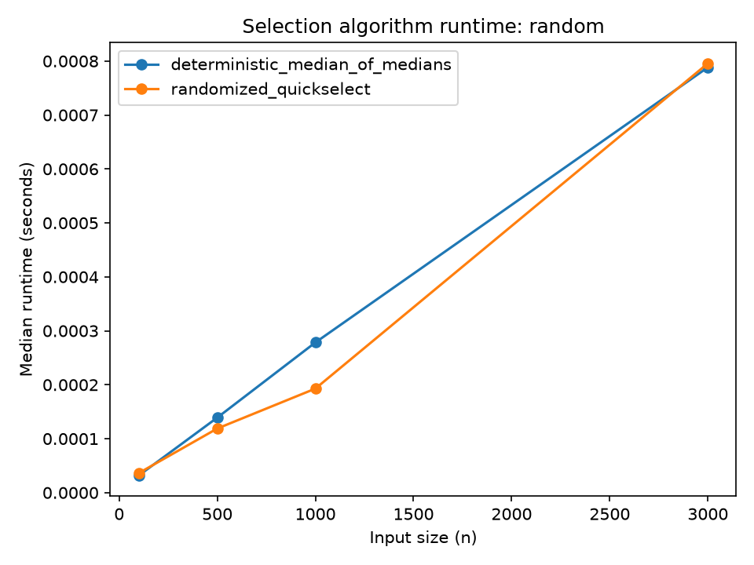
Fig. 1: Runtime comparison on random input
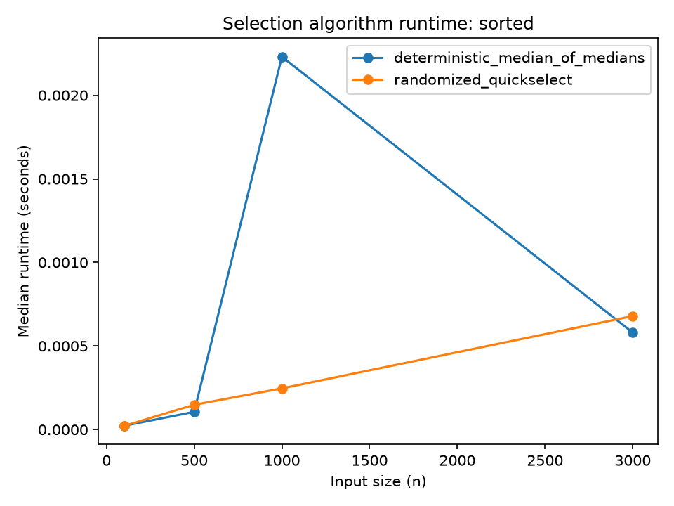
Fig. 2: Runtime comparison on sorted input
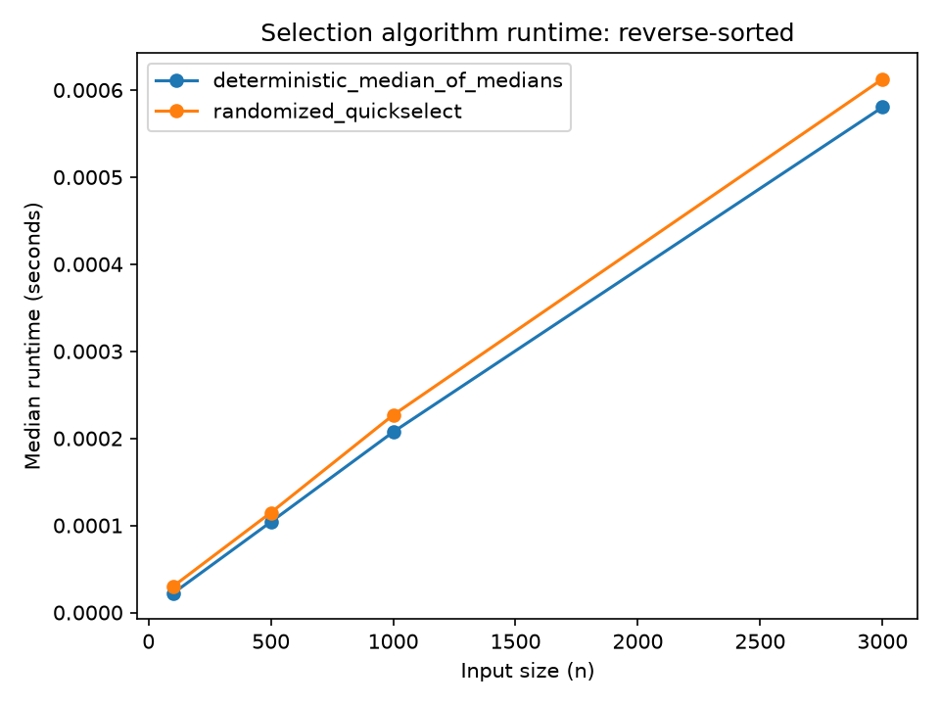
Fig. 3: Runtime comparison on reverse-sorted input
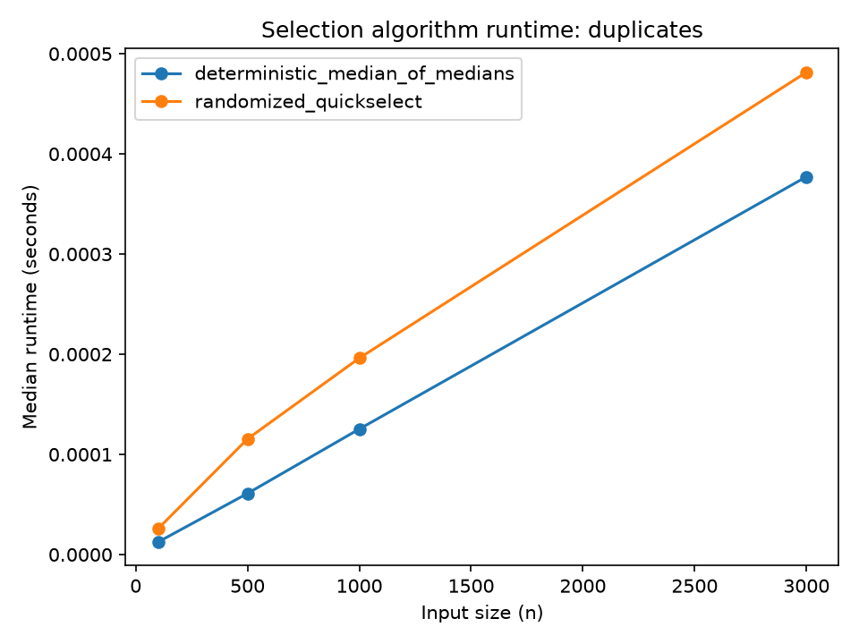
Fig. 4: Runtime comparison on duplicate-heavy input

Elementary data structures
The following is for an ArrayList wrapper: Get by index: O(1); Insert at an arbitrary position: O(n); Remove at an arbitrary position: O(n); since insertion or removal of an arbitrary position requires the insertion or removal of all the elements after that position. The Matrix class validates rectangular shape, and makes access O(1) and row removal or insertion O(r), for r rows (excluding the time to validate/copy the contents of the row being removed or added). These are appropriate for workloads which require high levels of indexed access, and for tabular data.
The Array based stack is a stack of LIFO. Pop/push (possibly resize) in O(1) amortized; peek in O(1). Circular buffer queue has the property of being FIFO (first in first out), enqueue and dequeue operations can be done in O(1) amortized time, resizing will take O(n) time. Stacks can be used to undo an operation, in the parsing of expressions, and in the handling of function calls, and queues can be used to implement task scheduling, buffering, and breadth-first processing.
In each node, the number is stored in a singly linked list as well, along with the node reference to the node with the next number. Prepending and deleting the head are O(1) while accessing by the index, searching, traversal and append (without a tail pointer) are O(n) (Sarevska et al., 2024). Although it is not needed to shift elements, a linked list has the overhead of each node's pointer and the per-node memory overhead, and has poor cache locality compared to an array but can be efficient for inserting new elements if the position for the insertion is known. Tests for empty structures, bad indices. The assignment did not include "rooted" trees.

Conclusion
In all cases tested, both the selection algorithms could provide appropriate order statistic. The worst-case time guarantee of Median of Medians is linear, and randomized Quickselect is expected linear time and is sometimes very cheap. The suggestion of essentially linear growth in the benchmark might be because of the outlier case sorted-input. There can be no single representation that is best for all workloads, for which indexed access is the dominant operation, arrays are used, simple access at both ends, stacks/circular queues, local insertion and deletion, linked lists, and where the references to the nodes are available. This report should be given in with the source files and CSV export.

References
Alissa, M., Sim, K., & Hart, E. (2023). Automated algorithm selection: From feature-based to feature-free approaches. Journal of Heuristics, 29, 1–38. https://doi.org/10.1007/s10732-022-09505-4
Sarevska, M. (2024). Data structures comparison for element deletion including stack and queue. WSEAS Transactions on Communications, 23, 114–120. https://doi.org/10.37394/23204.2024.23.15

